Range and Velocity Estimation of a Moving Target

P. Sai Teja

Correlation Processing and End-point detection are two methods used in radar signal processing.

**Correlation Processing:**  Cross Correlation tells us about the similarity between two signals at different time shifts. The reflected signal from the object is generally a delayed and attenuated version of the transmitted signal. So, the delay at which the signals has the maximum correlation tells us how much the signal has shifted, which tells us the range of the object.

**Algorithm:**

1)Get the transmitted pulse and correlate it with the captured signal.

2)Find the shift at which the correlation is maximum.

3)Calculate the range of the object from the obtained shift

**End-point detection:**  In a speech signal, there are parts of information tones and silent tones. In speech processing, End point detection is used to detect the start and end points of information tone. Energy of the signal or mean of the absolute values of the signal is calculated for a window and this window is shifted and again energy is calculated is till the entire signal is traversed. The resulting short-term energy or magnitude array is analyzed and the energy of the window which are above the selected threshold are part of the information of the signal. The beginning of the signal gives us how much the signal has shifted, which gives us the range of the object.

**Algorithm:**

1)Set window size as N.

2)Calculate the mean of the absolute values of the samples in the window and store in the short-term magnitude array.

3)Shift the window and again calculate and store the result till the end of the signal.

4)Set a threshold to select the windows that has to be decided as received signal.

5)Detect points as the beginning and end points of the retrieved signal which are consecutive and whose sequence length is greater than a predefined length.

6)Calculate the range based on the beginning of the detected signal

**Values set to the parameters in this analysis:**

Window size=5

Threshold=0.2*(maximum value in short-term magnitude array)

Difference between values to be decided as consecutive <=3

Minimum required sequence length=50

Axial velocity can be calculated from the above methods by calculating the range calculated between successive pulses and acquisition time between pulses. Assuming time period of the pulse is less than the time period of the oscillation.

**Transmitted signal**

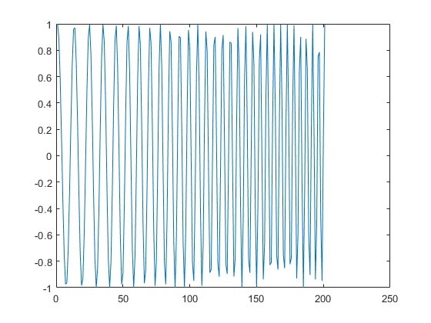

**Correlation Processing**

**Results upon data without noise**

Range of the object at various time instances

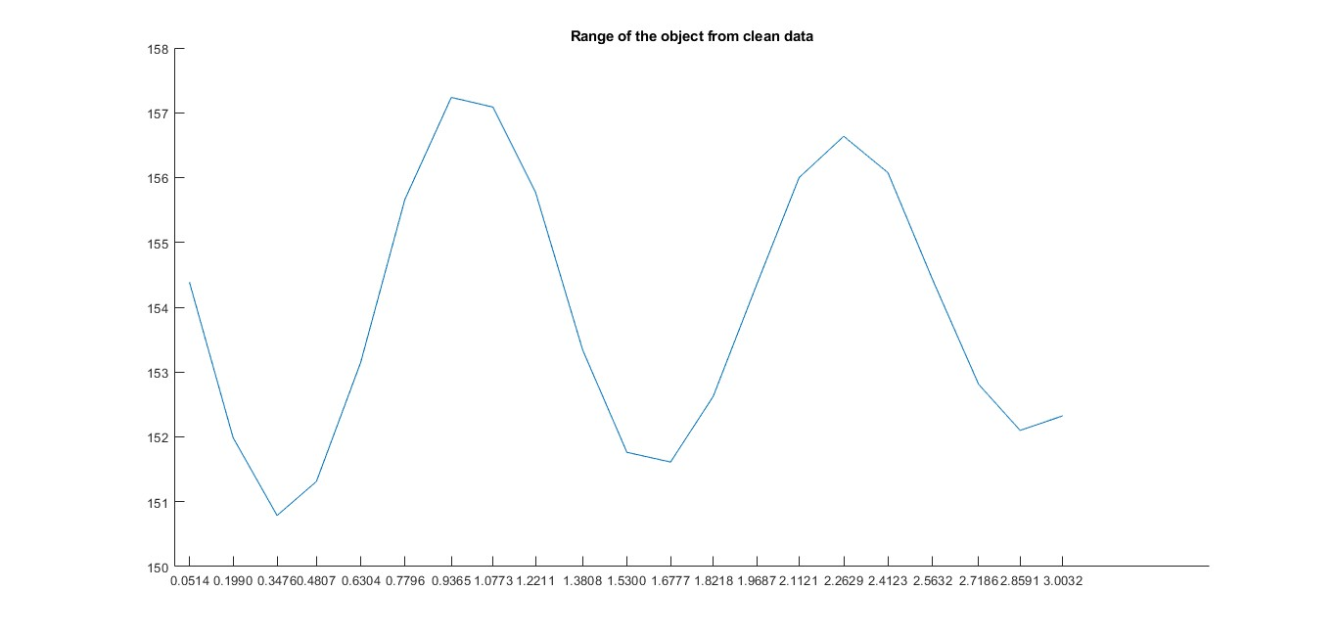

Velocity of the object at various time instances

The data of velocity intuitively resembles the velocity of the pendulum. Highest at least point and least at the highest point.

**Results upon data with noise**

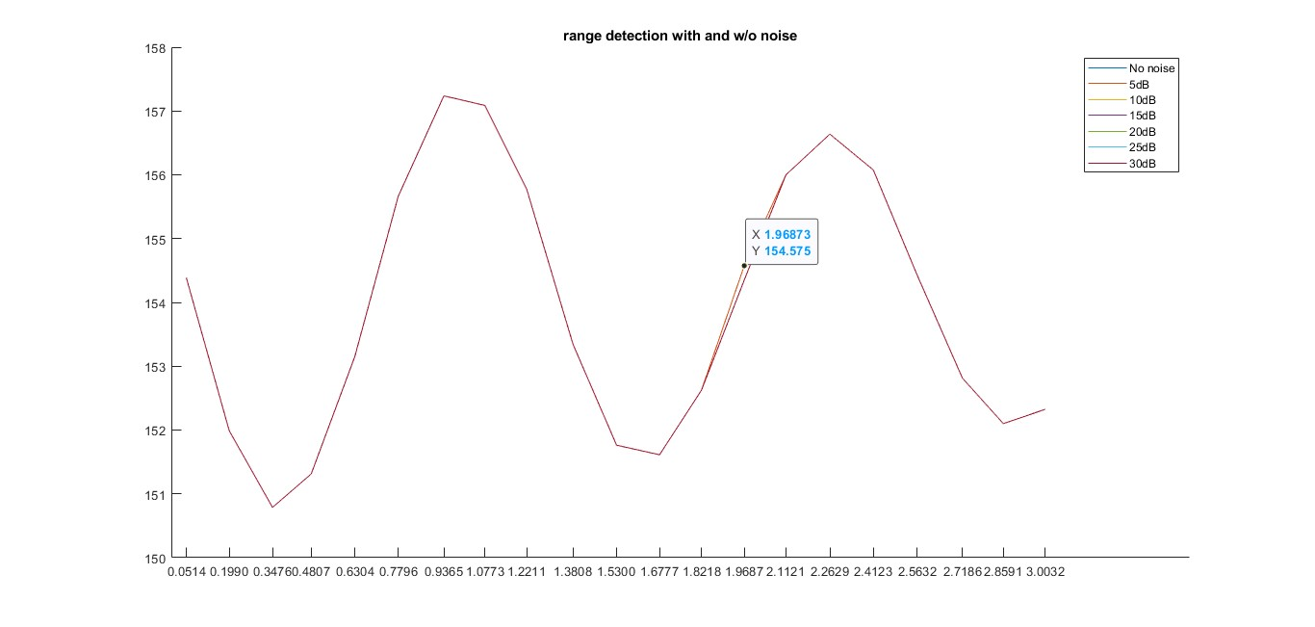

There are very few errors at low SNR of the signal.

Velocity of the object at various time instances

There are very few errors even at low SNR.

**End Point Detection**

**Results upon data without noise**

Range of the object at various time instances

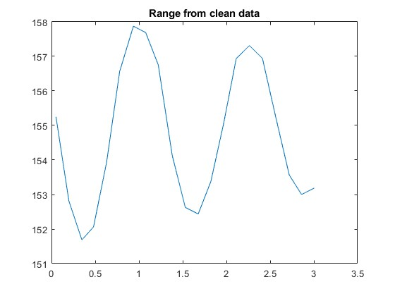

The range is bit deviated from the one obtained from the correlation processing. This may be due to selection of parameters that needs more tuning to give a bit more precision.

Velocity of the object at various time instances

**Results upon data with noise**

Range of the object at various time instances

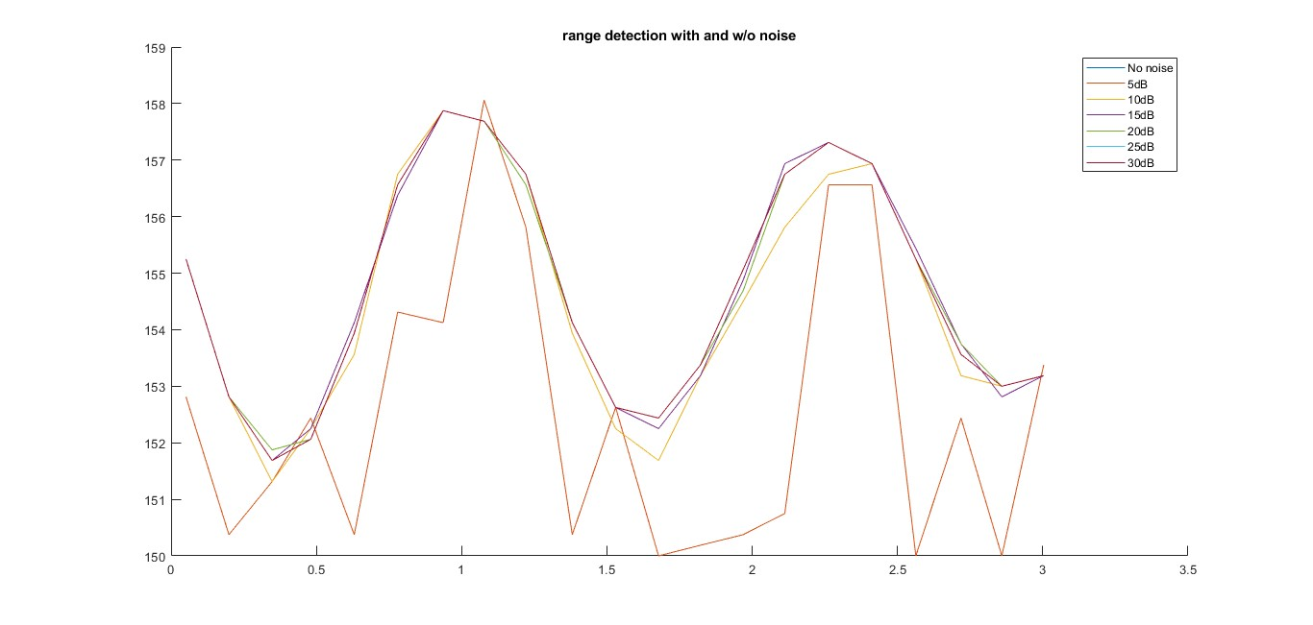

The data is completely deviated from the clean data results especially at low SNR.

Velocity of the object at various time instances

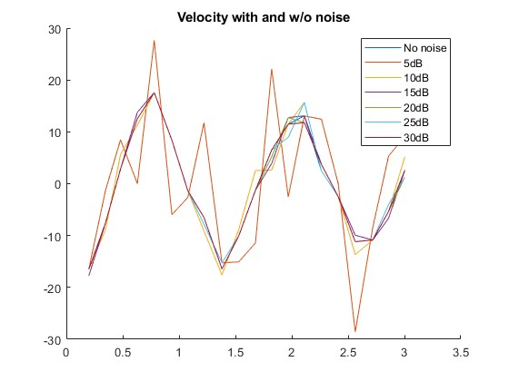

**Inferences:**

Based on the results observed after adding noise at various SNR’s.

1. Correlating processing has very negligible error even after adding SNR.
2. For End Point Detection the error is more at very low SNR.

As per the noise removing method mentioned in [1], short-term magnitude array has been modified by treating average of the minimum 30 samples as absolute noise and subtracted. This filtered data is again processed to check the results.

**Range of the object at various time instances after prefiltering for End-point detection:**

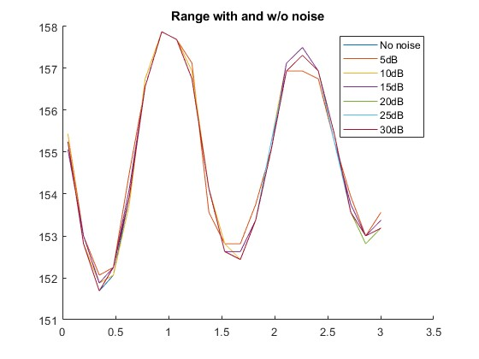

Prefiltering decreased the deviation of low SNR result from the no noise signal.

**Velocity of the object at various time instances after prefiltering for End-point detection:**

**Conclusions:**

* Correlation processing is giving better results compared to end-point detection. So, it is better to use correlation processing when the transmitted pulse is known.
* End-point detection is helpful when the transmitted pulse is unknown.
* End-point detection requires parameters to be tuned to get better performance whereas correlation processing doesn’t.
* Correlation processing requires computation of order N^2 whereas End-point detection requires computation of order N which gives it a huge advantage for a signal of length N.

**References**

1) E. A. Escoto-Sotelo, E. Escamilla-Hernandez, E. Garcia-Rios and H. M. Perez-Meana, "Endpoint Detector Algorithm for Speech Recognition Application," CONIELECOMP 2012, 22nd International Conference on Electrical Communications and Computers, Cholula, Puebla, Mexico, 2012, pp. 252-256, doi: 10.1109/CONIELECOMP.2012.6189919.

2) M. Jalil, F. A. Butt and A. Malik, "Short-time energy, magnitude, zero crossing rate and autocorrelation measurement for discriminating voiced and unvoiced segments of speech signals," 2013 The International Conference on Technological Advances in Electrical, Electronics and Computer Engineering (TAEECE), Konya, Turkey, 2013, pp. 208-212, doi: 10.1109/TAEECE.2013.6557272.